Senior Thesis in Electrical Engineering

University of Illinois Urbana-Champaign

Advisor: Professor Yang Zhang

CTurtlebot – a turtle inspired soft-robot

May 2023

By

Stephen Zhu

**Abstract**

The goal of this project is to design and prototype an untethered soft robot, capable of traversing across 2D surfaces, as a test bed for hysteresis-based control systems. To achieve this, we chose cable-driven silicone rubber actuators as the primary method of movement, due to their compliant and elastic nature. In addition, we created and 3D-printed a prototype chassis as an intermediate for testing the actuators. Lastly, we designed a custom PCB to control the actuators and enable an untethered design.

Since silicone rubber has a high coefficient of friction, the biggest challenge of this project is overcoming the friction of the actuators in only one direction to create a net motion. To overcome this, we first tested different types of rubbers of varying stiffness to determine a balance between the force required to actuate the actuators and the capability of the actuator to move the robot with its elasticity. After choosing a material to work with, we experimented with having the actuators flat on the ground versus approaching the ground at an angle, introducing curvature into the actuator. Analyzing the results through motion capture and videos, we found that the “curved” actuators created more net movement, since the edge of the actuator caught and pushed off of the ground more compared to the flat actuator. Finally, we added different shapes to the edge of the actuators to see if we could further improve performance.

Subject Keywords: Cable-driven actuators; Soft robotics; Crawling robot

Contents

1. Introduction 1

2. Literature Review 4

3. Description of Research Results 7

3.1 Initial Design 7

3.1.1 Actuators and Testing Procedure 7

3.1.2 3D-Printed Body 10

3.1.3 Circuitry and Programming 12

3.2 Actuator Optimization 13

3.2.1 Redesigning the Actuators 13

3.2.2 Motion Capture Results 16

3.3 Final Designs 19

3.3.1 Custom PCB Design 19

3.3.2 Soft Body Development 21

3.3.3 Motion Capture Results 22

4. Conclusion 26

References 27

# 1. Introduction

In places inaccessible to human beings, there is a need for small robots. For example, pipes are useful for transporting radioactive chemicals, pressurized fluids, and sewage. However, they can wear down over time and develop internal fractures that may not be visible externally. If left unaddressed, the pipes may continue to deteriorate until they start leaking. Robots can be used to detect these types of problems, so that they can be addressed before any major issues form.

Soft robots present an interesting solution to these types of problems [1]. Unlike traditional robots, soft robots are made with compliant materials, which can be squeezed or stretched. This property allows for greater adaptability to situations like small spaces or uneven terrain that traditional robots may struggle in. In the case of materials like silicone rubbers, which are inert, radioactive environments or those with gas leaks may be traversed safely. Lastly, the self-healing nature of materials such as hydrogels can be more robust than rigid materials, on which damage is permanent.

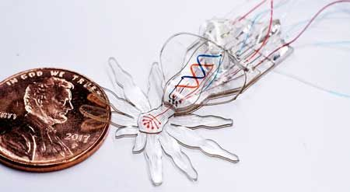

Figure . An example of a pneumatic, spider-shaped soft robot [2].

One tool used in tandem with soft robots is soft actuators. Since they are compliant, there is less risk to the environment when using them, as opposed to using rigid materials. For example, grippers utilizing soft actuators are being developed to harvest fruit [3] and handle food [4] without damaging them, a task that is significantly harder with traditional grippers. For this reason and the lower cost of production, soft actuators prove to be an integral part in the development of soft robots.

However, since compliant materials lack a rigid structure, they are often harder to model and control compared to their rigid counterparts. The goal of this project is to create an untethered, crawling soft robot as a testbed for the modeling and control of soft actuators; more specifically, cable-driven, hysteresis-based actuators. The robot is inspired from the movement of turtles, which use their flippers to drag their bodies on land.

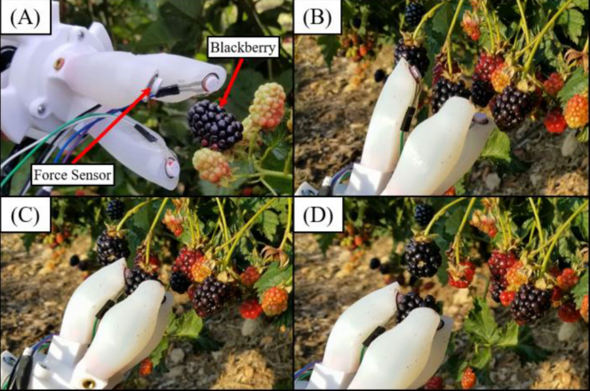

Figure . An example of a soft gripper used to harvest blackberries [3].

Over the course of this project, we developed actuators similar to the flippers of a turtle. However, when 3D-printing a prototype body, we realized that it was difficult to produce a net motion of the robot, since the flippers generated equal frictional force in both directions. To counteract this, we iterated through multiple designs until we succeeded in reducing the friction in one direction for the actuators. After creating a custom PCB to control the robot and a mold for a completely soft body, we then used a motion capture system to record the net velocity of our prototype.

From our results, we can conclude that while the soft body does decrease the net velocity of the robot, the unidirectional friction-reducing actuator design can still be used to move our soft robot. Thus, we have created a viable, untethered testbed utilizing hysteresis-based actuators.

# 2. Literature Review

Going into the project, we already had the idea of creating a turtle-shaped robot, and some work has already been done covering the use of ionic polymer-metal composites (IPMC) actuators to create the flippers for a turtle shaped robot [5]. Once a voltage is applied to the actuators, they bend, enabling movement of the flippers and the robot. While the this robot was meant to swim in water, we began considering using a similar flipper shape for land-based movement.

Another design choice that we wanted was to make the robot untethered; in other words, able to function without wires or tubes connecting the robot to an external system. This way, our robot will be able to traverse long pathways without a maximum length constraint. When searching for papers, we found concerning a crawling robot with an “origami body,” with legs on the bottom bent at 45o to enable directional friction [6]. Mounted on the actual body of the robot is a light DC motor, which pulls a bistable beam attached to the front and back of the robot. This robot is powered through a single wire to power the DC motor, so it is not completely untethered. However, we saw that if we could mount a battery on top of our robot and use a motor to actuate a cable-driven design, we would likely achieve a fully untethered design.

(a) (b)

Figure . (a) A picture of the turtle-shaped IPMC robot [5]. (b) A picture of the bistable beam actuated origami robot [6].

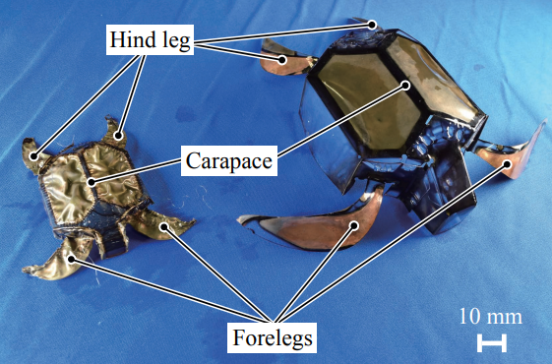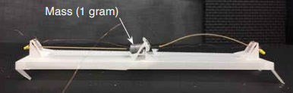

One other interesting part of the previous paper is the mention of direction friction due to the bending of the legs. Ultimately, this and the joint of the robot foot mentioned in a separate paper [7] can be loosely categorized under hysteresis-based motion. In other words, similar to how a piano key works, when the mechanism is activated, the robot/joint/key travels along a certain path. However, when returning to the initial state, a different path is taken. For the crawling robot, the bent legs cause a net movement. For the robotic foot, the unlocking of the “ankle” joint enables more accurate mimicry of the motion of an actual human foot. For a piano key, the corresponding string is struck by the key’s hammer when the key is depressed, but not when released, resulting in only one note being played. Depending on the efficiency of our actuators, we reasoned that we could potentially add “legs” to the bottom, which would help generate directional friction.

Lastly, an actuator similar to the one we planned to design was developed to make a quadruped crawling robot [8]. However, while the robots in the paper are technically untethered, they rely on an external system to pneumatically pressurize the actuators to their initial state. For this reason, we wanted to change the design so that it would only rely on cables, thus eliminating the need for an external system and achieving better modularity. Given the size of this paper’s robot, we also wanted to reduce its overall size and complexity by using only two actuators instead of four. This choice would enable our robot to fit into smaller spaces and save time and material when designing a prototype. Lastly, we wanted to create a soft body for the robot, in comparison to the rigid casings used with this paper’s robots.

Figure . A picture of the hysteresis-based robotic foot [7].

Figure . A picture of the pneumatic/cable hybrid crawler [8].

# 3. Description of Research Results

## 3.1 Initial Design

### 3.1.1 Actuators and Testing Procedure

To begin, we had to decide on the actuator design. We wanted something similar to the designs presented in previous works [4, 8]; however, instead of being dependent on pneumatics, we wanted an exclusively cable (or tendon) based design. Figure 6 shows the various terms used to constrain the actuator’s dimensions. For simplicity, we decided to have the indents (described in the Figure 6 caption) remain consistent across all actuator designs, so that we could accurately compare the different actuators’ performance, which is defined later. The tips of the indents are spaced 20 mm from each other, and the flat sections between the indents are 5 mm long. For the same reason as before, we held the length constant at 75 mm.

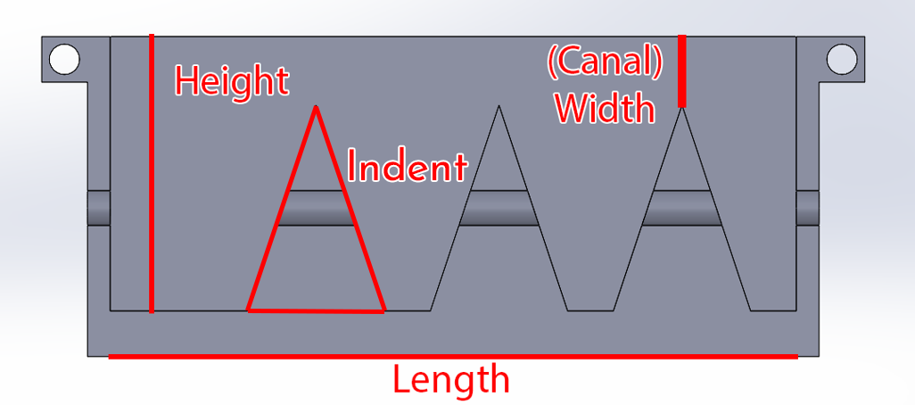 We then created a total of five sets of molds. The first four were to test a height of 15 mm vs 30 mm, as well as a width of 2.5 mm vs 7.5 mm. These molds had a thickness of 12 mm, and the fifth mold had a height of 30 mm, width of 7.5 mm, and thickness of 25 mm to see if thickness had an effect on performance.

Figure 6. A diagram of half of an actuator mold depicting the various terms used to describe the dimensions of the actuator. The thickness of the actuator is represented as the dimension going into and out of the page. The triangular sections form the indents of the actuator. The left side is the base end, where the cable is pulled.

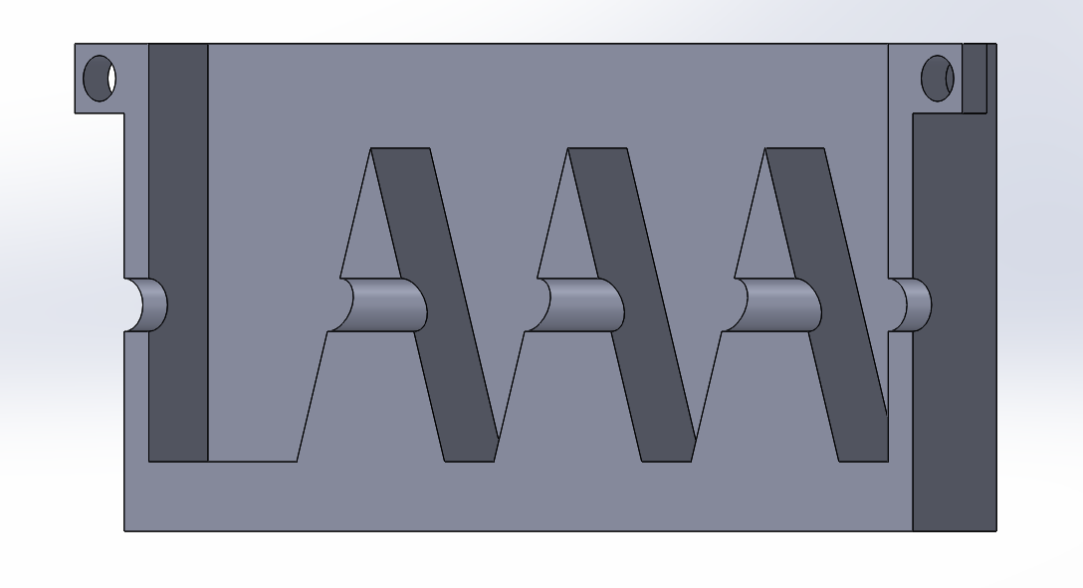

Figure 7. A 45o angle view of the mold in Figure 7. In this view, the cylindrical cavity present within the mold is clearer to see.

To make the actuators, each set of molds is split in half and 3D-printed individually. A tube is then placed within the cylindrical cavity formed by both halves of the mold pressed together, as shown in Figure 7. The two halves are then held together by inserting screws into the holes on the sides of the molds. Lastly, the selected material is poured into the mold to create the soft actuator. Once the material cures, the sections of tubing not encapsulated by the material are then removed, to allow the actuator to bend properly. Figure 8 is a picture of a completed actuator.

Three different silicone rubbers were used to make actuators from these five molds. The first was Body Double, a silicone rubber ultimately cured too fast and trapped too many bubbles to make reliable actuators. As a result, we did not fabricate any actuators for testing using this material. The second was Ecoflex 50, a silicone rubber that made soft and easy to bend actuators. The last was Dragon Skin 30, a silicone rubber that made stiffer actuators that required more force to bend.

To test the performance of the actuators, we made a simple procedure to determine how much weight it would take to fully bend each of the actuators. Each actuator was put on top of a table, with the base end aligned with the edge of the table. Then, weights were attached to the end of the cable to bend the actuators.

Figure 8. A picture of a completed actuator, with a height of 30 mm, a width of 7.5 mm, and a thickness of 12 mm. The cable used to drive the actuator is a section of fishing line, and the washer on the left side is used to help keep the cable attached to the end of the actuator.

Figure 9. A bar chart displaying the results of the actuator testing procedure.

Figure 9 displays the measured results of the procedure. What we found was that the actuators with a width of 2.5 mm and the actuators made with the Ecoflex 50 could be fully bent with at most around 200 g of weight. The 7.5 mm width Dragon Skin 30 required significantly more weight to bend. From these results, we reasoned that if we wanted to use these actuators to generate force to move a robot, we would need to use the actuators which required more weight, since the force generated by the elasticity of these actuators was larger compared to the other ones. The actuator with 25 mm of thickness required marginally more weight to pull than its 12 mm counterpart, so we determined that further experimentation with thickness was unnecessary.

### 3.1.2 3D-Printed Body

To further compare the Dragon Skin 30 actuators with 7.5 mm of width, we needed to design a body (chassis) that could be moved by the actuators. We decided to CAD and 3D print a rigid structure for prototyping before moving onto a soft body. We also decided to make the area of attachment for the actuators sloped to ensure they would touch the ground, albeit at an angle. Figure 10 shows the front and back view of the 3D-printed body design.

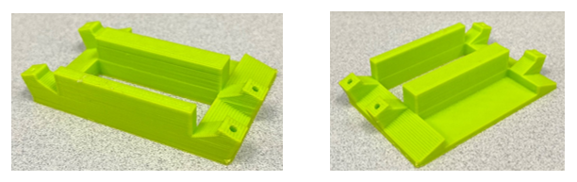

(a) (b)

Figure 10. The front view (a) and back view (b) of the 3D-printed body, made with PLA filament. The left side has a 15 mm wide slot to test the 15 mm tall actuators, and the right side has a 30 mm wide slot for the 30 mm actuators. The rectangular hole in the center is meant to hold a servo, which pulls the cables to activate the actuators. The back has a section meant for the breadboard to sit on, but we found it was easier to conduct the tests with the breadboard to the side.

The main purpose of this body was to retest all the actuators to see if the previous test procedure results translated to the testing done on the body. As expected, the only actuators capable of moving the body were the 7.5 mm width Dragon Skin 30 actuators. Additionally, we learned that because the 15 mm tall actuators were so stiff, they raised the printed body off the ground too much, which lead to instability when the actuators moved.

We then redesigned the body, to allow for a better fit for the servo and to allow 30 mm tall actuators to be placed on either side of the robot. Figure 11 is a front and back view of the updated design, with the servo and motion capture trackers attached.

Figure 11. The front view (top) and back view (bottom) of the updated body design.

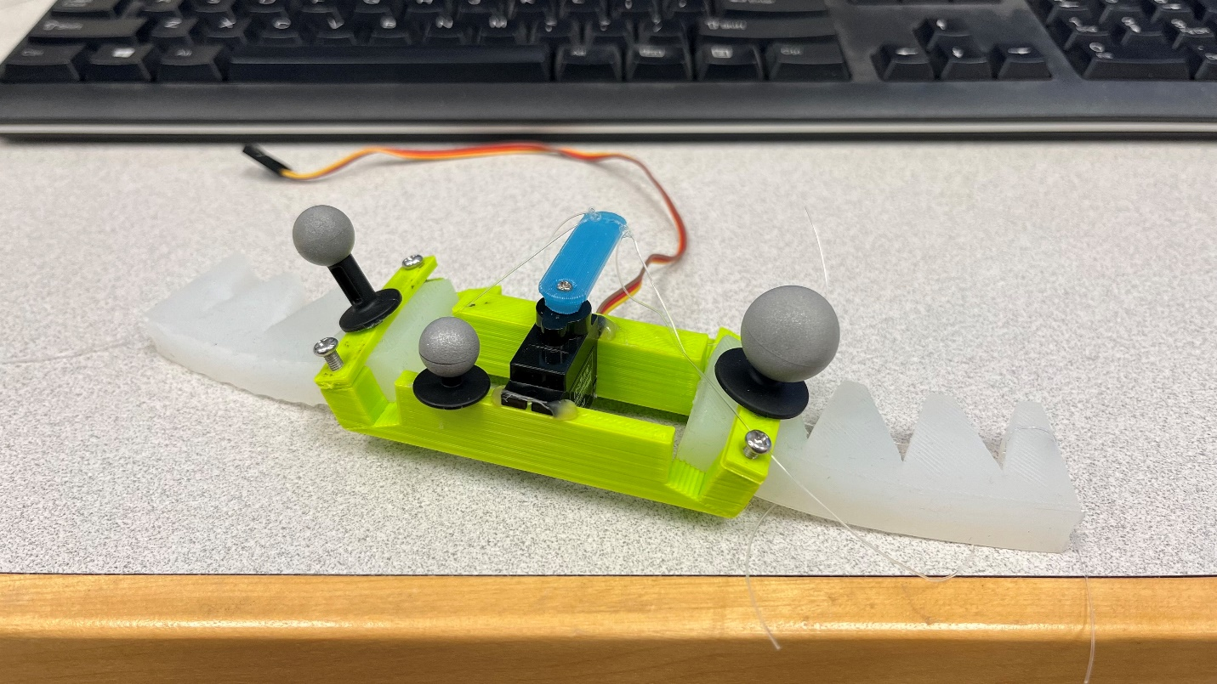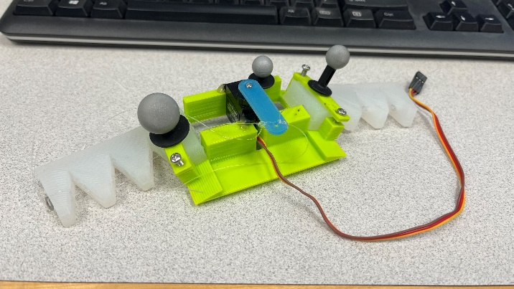

Figure 12. The results of the motion capture data. Here, Z signifies the forward direction of the robot. The slope of the line of best fit represents the net velocity of the robot with each actuator set.

With our motion capture system, we compared the net velocity of the robot with the 15 mm tall actuators vs the 30 mm tall actuators. Figure 12 displays the results of each run. From the data, the 15 mm tall actuators had an average net velocity of 0.84 mm/s, while the 30 mm tall actuators had an average of 2.08 mm/s. Using velocity as the main metric for performance, the 30 mm tall actuators performed better than the 15 mm tall actuators.

### 3.1.3 Circuitry and Programming

For our prototype, we used a simple breadboarded circuit. An ItsyBitsy 32u4 3V board is used to control a servo, which pulls the cables of the actuators to activate them. Since the board is Arduino compatible, the Arduino IDE was used for ease of implementation and controlling the servo. When using the motion capture system, we detached the ItsyBitsy from the computer and used a 3.7 V LiPo battery to power the system instead.

## 3.2 Actuator Optimization

### 3.2.1 Redesigning the Actuators

With a net velocity of only 2.08 mm/s, we wanted to see if there was a way to improve the robot’s performance by changing the actuators. Taking a closer look at Figure 11, we noticed that because the actuators were straight, they became bent from the weight of the robot, causing the front section of the robot to be lifted off the ground. Thus, as a first step, we tried introducing a bend in the base end of the actuators so that they would be flat on the ground. Figure 13 shows the difference between the normal actuator versus the bent actuator.

The results of testing the bent actuators on the printed body are shown in Figure 14. From the data, we see that the average net velocity is 0.34 mm/s, a clear decrease compared to the normal design. After taking a few videos and comparing the two types, we noticed that the normal design performed better due to the front edge of the actuator. When the normal actuators return to their initial state from their bent state, the edge of the actuator catches against the ground, creating directional friction and producing a larger net motion of the robot.

Referencing the leg designs in the previous works [6, 8], we began experimenting with different designs for the edge of the normal 30 mm actuator. With these designs, shown in Figures 15-16, we hoped to further increase “catch” of the edge and the directional friction. We tried implementing one large wedge, three small wedges, and one small wedge designs. We also experimented with reversing the direction of the wedges and reintroducing a bend in the base end of the actuator in case it worked better with the edge augmentations.

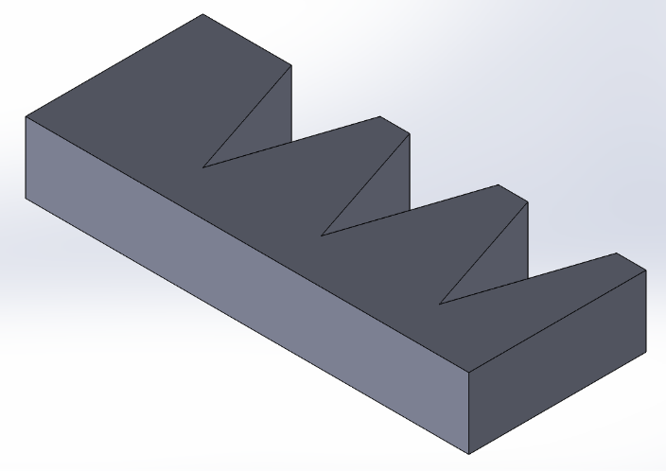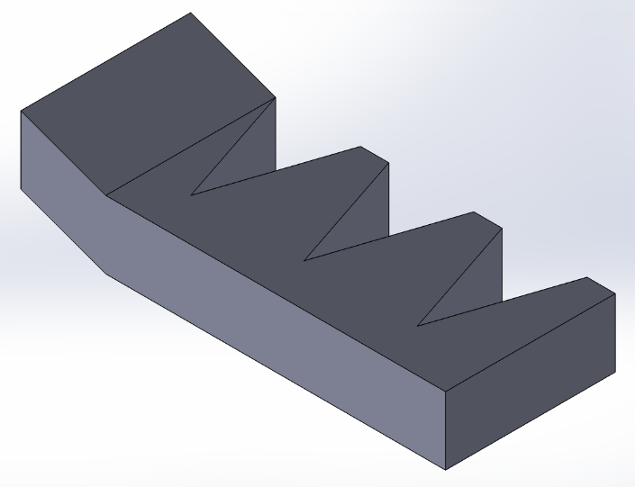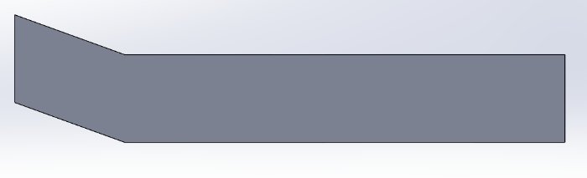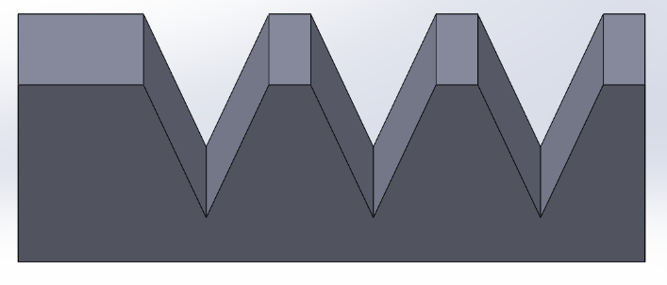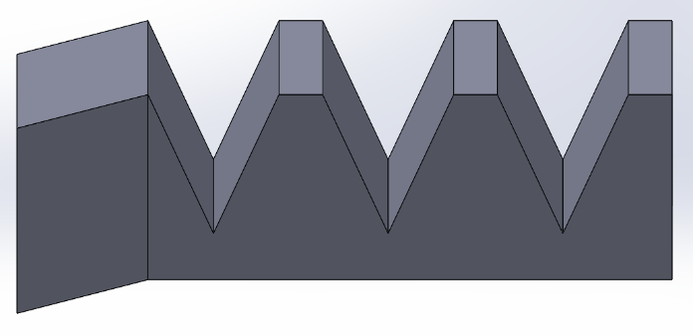

Figure 13. (a)-(c) are different views of the normal, flat actuator. (d)-(f) are the same views on the bent actuator.

(c)

(f)

(b)

(e)

(d)

(a)

**(a) (b)**

(c) (d)

Figure 15. Different adjustments to the edge of the actuator. (a) depicts one long wedge, (b) depicts three wedges, (c) depicts one wedge, and (d) shows the side view of all three designs.

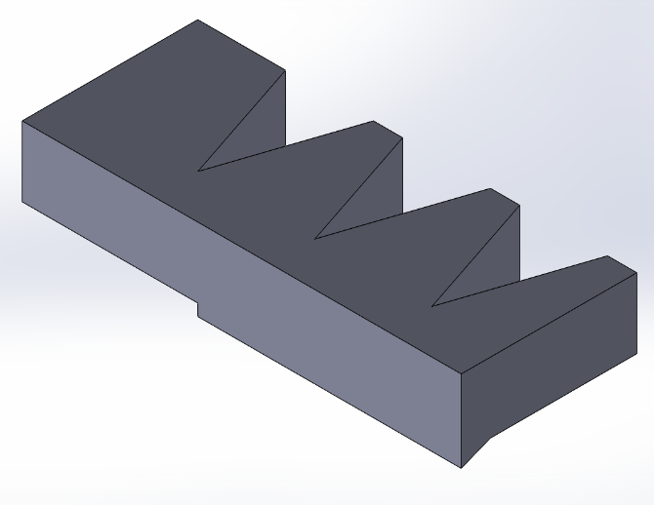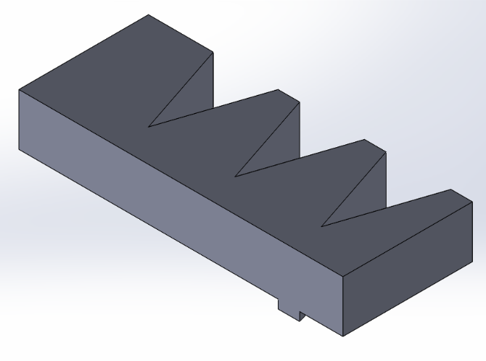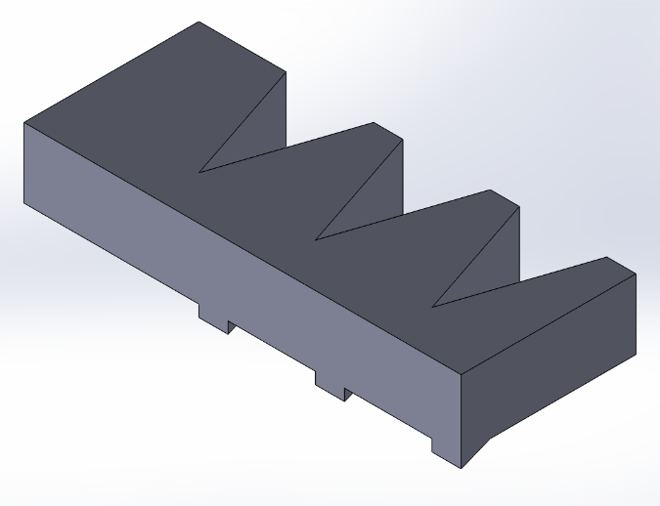

Figure 14. Data of the bent actuator design from the motion capture system.

Figure 16. Additional experiments with the actuator design. The left image shows the bending of the base end, as well as the addition of three reversed wedges. The right image depicts the side view of this design.

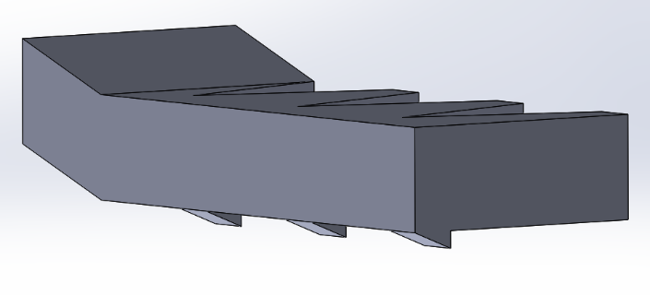

### 3.2.2 Motion Capture Results

When attempting to take data with the motion capture system, we immediately noticed that the single small wedge design, the designs with the reverse edge augmentations, and the designs with the bend in the base edge all seemed to reduce the directional friction, causing the robot to stay in place. Thus, we skipped taking data on them. The results of taking data for the single large wedge and the three small wedge designs are shown in Figure 17.

From the data, we saw that adding the edge augmentations did improve the average net velocity of the robot, and the three wedge design performed better than the one wedge design. We then tried to increase the speed of the servo to see if that would increase further increase performance. The result of increasing the speed of the servo by 10x is shown in Figure 18. As we can see, because the servo turned quicker, the overall “cycle” time to activate the actuators decreased, resulting in the robot being 4x as fast as before.

Figure 17. The top graph shows the data taken for the one wedge design, with the net velocity being 2.1 mm/s. The bottom graph shows the data for the three wedge design, with the net velocity being 2.6 mm/s.

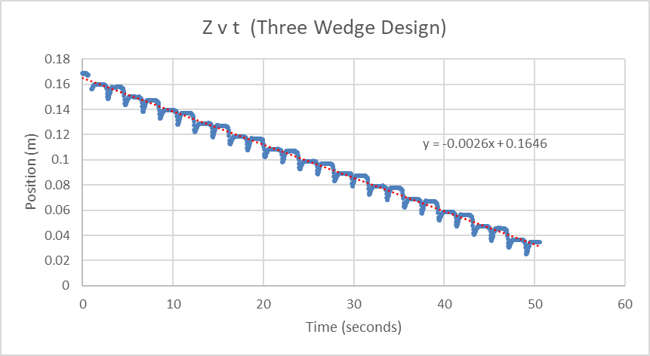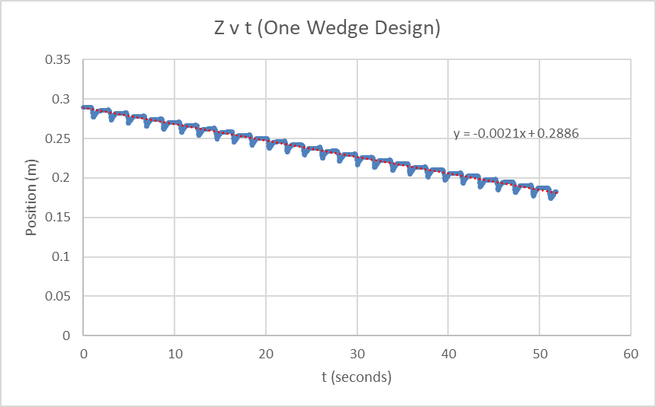

Figure 18. The data after increasing the servo speed by 10x with the three wedge design. The net velocity becomes 9.1 mm/s.

## 3.3 Final Designs

### 3.3.1 Custom PCB Design

Having achieved our goal of increasing the efficiency of the actuators, we shifted our attention to migrating the system onto an untethered soft body. The breadboard we had our circuit on was large and heavy, so we needed to create a custom circuit board to avoid these issues.

Before, we used one servo to pull the cables of both actuators. When swinging in one direction, one of the actuators would be pulled, and when swinging the other way the other actuator would be pulled. However, since it is impossible to make the actuators perfectly symmetrical, the robot would often tend to start turning either clockwise or counterclockwise over a long period of time. Thus, we needed another servo to control each actuator separately and to provide a framework for being able to control the robot at any time. We had only one copy of the previously used servo, which was unbranded, so we obtained several copies of a different servo from DigiKey.

This new servo model had several differences compared to the old servo. First, it couldn’t handle the same speed as the previous servo, so we had to reduce the speed of its rotation. In the end, we found that reducing it by 1/2x, or 5x the original speed was all the servo could handle. Second, the recommended voltage for the new servos was 5 V, which is larger than the 3.7 V battery used for the previous servo. To counter this issue, we decided to use a 3 V to 5 V voltage converter in our circuit.

Factoring these differences in, we then designed a schematic and board using Eagle, which are represented in Figure 19. An equivalent block diagram is shown in Figure 20. We added a 2 pin connector to the board, so that we could connect the batter to power the voltage converter and the ItsyBitsy. Additionally, we could not find exact parts online or within the Eagle libraries, so we used other equivalent parts to create the vias for the motors and ItsyBitsy board.

Figure 19. The top diagram is the schematic of the circuit, and the bottom diagram is the PCB designed within Eagle.

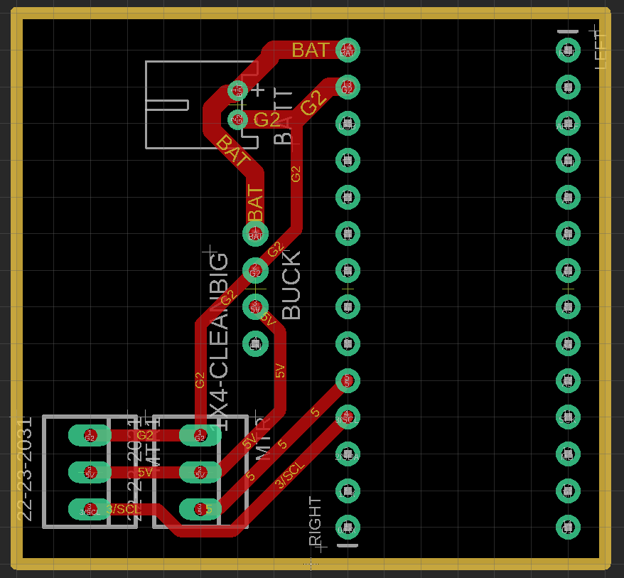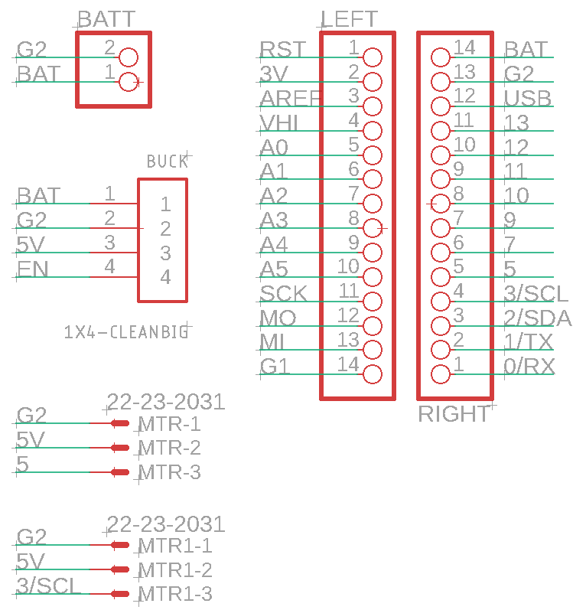

Figure 20. A block diagram of the circuit.

### 3.3.2 Soft Body Development

We first tried to make a mold based off of our previously printed body. However, this posed three issues. First, because there was so much open space surrounding our servos, the servos would twist in place rather than pull the cable to drive the actuator. To fix this issue, we recreated the mold so that the servos would be surrounded by material to be held in place. Second, we originally used screws to clamp down the actuators against the printed body, which would be significantly harder with the soft body. Instead, we removed the clamp and decided to use more silicone rubber to “glue” the actuators to the soft body once they were taken out of the molds. Lastly, we did not have a place to hold the circuit board or the battery. We then created compartments for both the circuit board and the battery, so that we could glue them on with more material like the actuators.

Figure 21 shows different angles of the soft body mold, while Figure 22 shows pictures of the entire robot put together.

### 3.3.3 Motion Capture Results

Figure 23 shows the data taken of the soft body robot. As expected, having a soft body produces more friction overall in comparison to a 3D printed body, so the performance decreases. As mentioned before, the speed of the servos was reduced, which likely also contributes to the decreased performance. Lastly, due to the soft body, the body itself bends a little bit, which in turn bends the actuators less. Thus, there is less pressure against the wedges of the actuator, which causes less directional force to be generated.

Figure 21. The top image shows the front side of the mold, while the bottom image shows the back view of the mold.

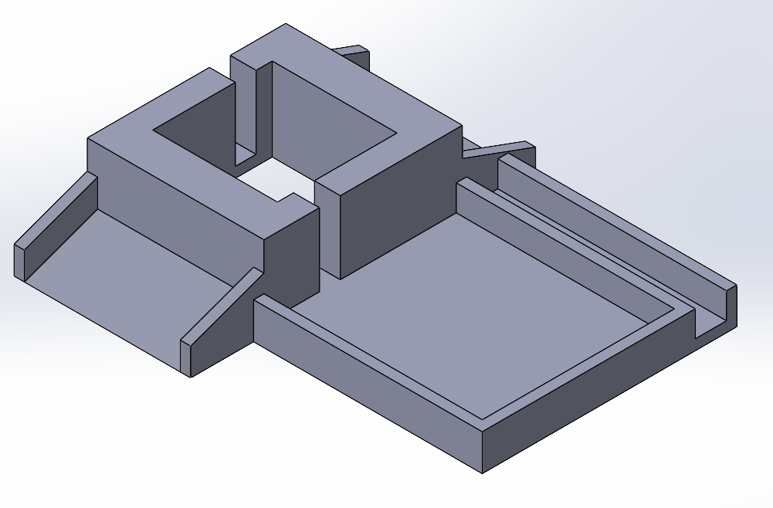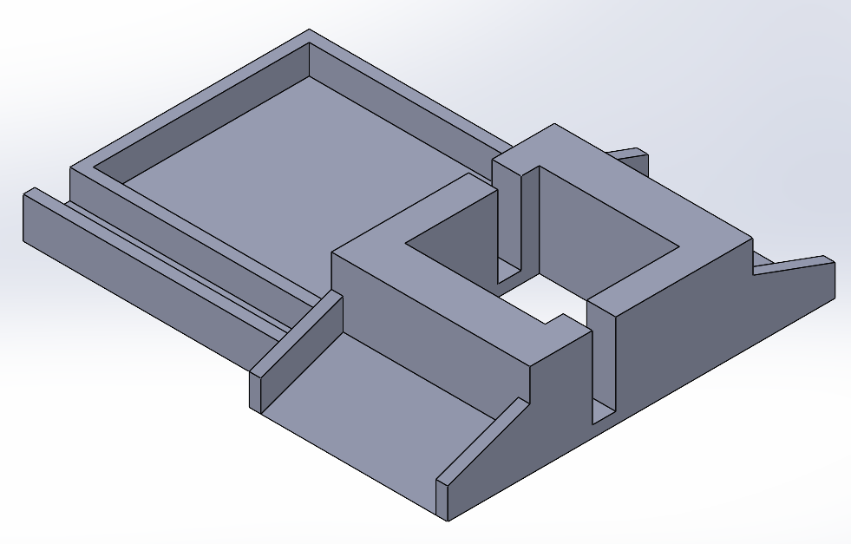

Figure 22. The top picture is the front view of the robot, while the bottom picture is a birds-eye view of the robot.

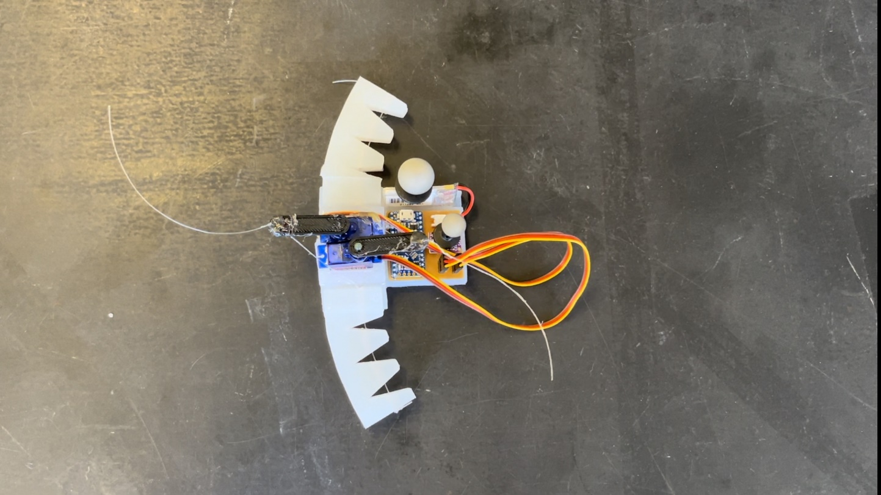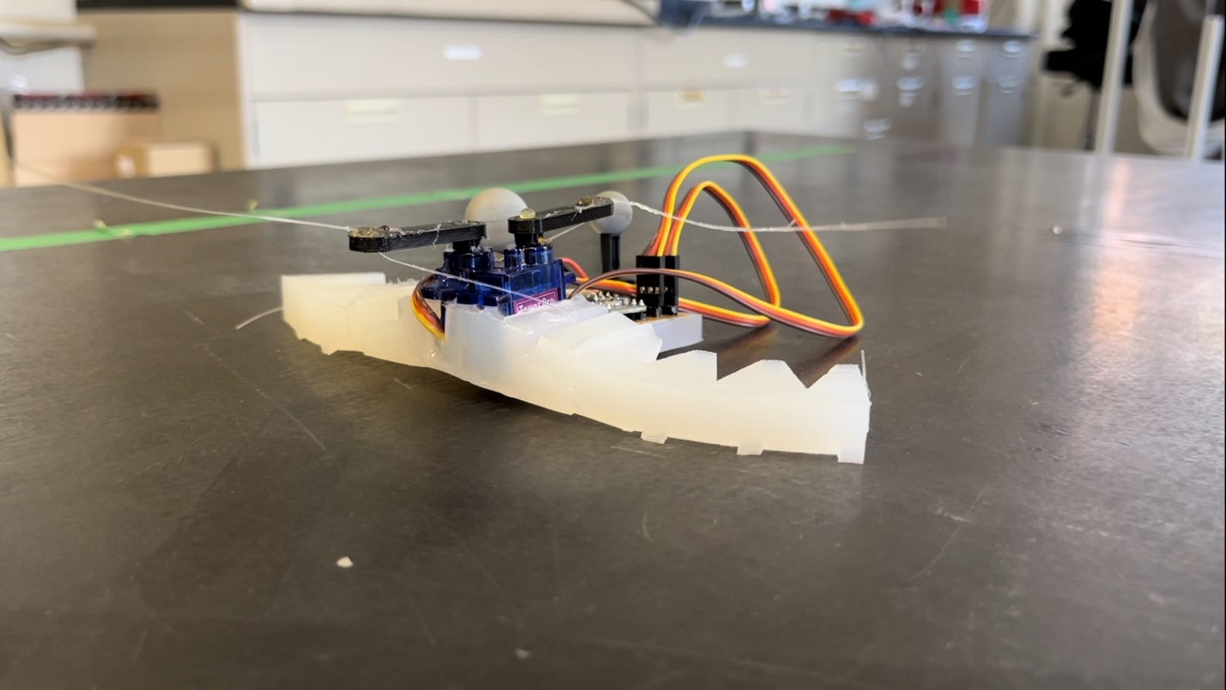

Figure 23. Motion capture data of the soft body robot. The average net velocity of the robot is around 4 mm/s.

# 4. Conclusion

Ultimately, we have created a soft robot, untethered through the use of a battery. We first determined the actuator design and specific parameters we wanted to test. After deciding on the design, we 3D printed a body to see the performance of our actuators. From the resulting motion capture results, we experimented with different edge designs to further improve the performance of the robot by increasing directional friction. Lastly, we created a soft body and provided a framework to control the robot using two servos and the ItsyBitsy board.

We believe that there are many potential improvements and many avenues to explore with the testbed we have created. Further study of different types of wedges or methods to create directional force could improve the robot’s velocity. The design of the soft body can be adjusted to enable underwater movement on top of its land-based movement. Sensors or a means of wireless communication can be used for better control of the robot, and cameras can be attached for wireless data collection. Lastly, the modularity of the robot can be improved, so that it would be easier and quicker to construct.

# References

[1] Hu ZJ, Cheneler D (2021) Bio-Inspired Soft Robot for Locomotion and Navigation in Restricted Spaces. J Robotics Autom 5(1):236-250.

[2] Ranzani T, Russo S, Bartlett NW, Wehner M, Wood RJ. Increasing the Dimensionality of Soft Microstructures through Injection-Induced Self-Folding. Adv Mater. 2018 Sep;30(38):e1802739. doi: 10.1002/adma.201802739. Epub 2018 Aug 6. PMID: 30079470.

[3] A. L. Gunderman, J. A. Collins, A. L. Myers, R. T. Threlfall and Y. Chen, "Tendon-Driven Soft Robotic Gripper for Blackberry Harvesting," in IEEE Robotics and Automation Letters, vol. 7, no. 2, pp. 2652-2659, April 2022, doi: 10.1109/LRA.2022.3143891.

[4] Z. Wang and S. Hirai, "Chamber dimension optimization of a bellow-type soft actuator for food material handling," 2018 IEEE International Conference on Soft Robotics (RoboSoft), Livorno, Italy, 2018, pp. 382-387, doi: 10.1109/ROBOSOFT.2018.8404949.

[5] H. Nabae et al., "Design and Fabrication of 3D Papercraft IPMC Robots," 2022 IEEE 5th International Conference on Soft Robotics (RoboSoft), Edinburgh, United Kingdom, 2022, pp. 95-102, doi: 10.1109/RoboSoft54090.2022.9762212.

[6] W. Yan and A. Mehta, "A crawling robot driven by a folded self-sustained oscillator," 2022 IEEE 5th International Conference on Soft Robotics (RoboSoft), Edinburgh, United Kingdom, 2022, pp. 455-460, doi: 10.1109/RoboSoft54090.2022.9762079.

[7] K. Enomoto, T. -Y. Chen, T. Kawasetsu and K. Hosoda, "Design of a Robotic Foot with Midtarsal Joint Locking Mechanism," 2022 IEEE 5th International Conference on Soft Robotics (RoboSoft), Edinburgh, United Kingdom, 2022, pp. 1-6, doi: 10.1109/RoboSoft54090.2022.9762172.

[8] S. Gong, J. Wu, T. Zheng, W. -M. Zhang and L. Shao, "Untethered Cable-driven Soft Actuators for Quadruped Robots," 2021 27th International Conference on Mechatronics and Machine Vision in Practice (M2VIP), Shanghai, China, 2021, pp. 417-422, doi: 10.1109/M2VIP49856.2021.9664995.